
Mobiquest Solutions Pte Ltd
6 Ubi Road 1, Wintech Centre #05-13, Singapore - 408726
Tel: 65-67493202, Fax: 65-67493212
Email: info@mobiquest.net
URL: www.mobiquest.net

Document | MobileFirst Platform Studio Plugin – Installation Guide
Release Version | 1.0
Release Date
Approval Date

VERSION HISTORY

Version # | Release Date | Description | Updated By
1.0 | 21st Dec 2016 | Installing MobileFirst Platform Studio Plugin & iFix | Reej

TABLE OF CONTENTS

1 Purpose 3
2 MobileFirst Platform – V6.3 3
3 Steps Involved 3
4 Download the Plugin & iFix 3
5 Installing the plugin 3
6 Adding the iFix as Eclipse P2 Update 5

Purpose
This document describes how to add the Mobile First Platform Studio Plugin in Eclipse.

MobileFirst Platform – V6.3
We can add the mobile first studio plugin in eclipse through eclipse market place. But Eclipse market place provides only the current available version in the market for download. If we need to add an older version of studio plugin to eclipse, we need to get it from IBM Partner World.

Steps Involved
- Install eclipse version that supports mobile first v 6.3 (E.g. : Juno SR2)
- Download the mobile first plugin (v6.3) -
- Download the iFix if any available for the version.
- Install the plugin.
- Add the IFix as archive.
- Update the plugin.

Download the Plugin & iFix
- Ensure the required plugin & iFix (if required) to be added for this version (MobileFirst – v 6.3)
- Download the plugin - MFPF_6.3_CE_ELP_UPD_IBM_MF_STUDIO.zip and
- Download the iFix - 6.3.0.0-MFPF-StudioP2-IF201609272209.zip from the IBM Partner world website (Available only to IBM Partners)

Installing the plugin
Once the plugin has been downloaded, follow the below steps to install the mobile first studio plugin in eclipse.
- Go to Help → Install New Software
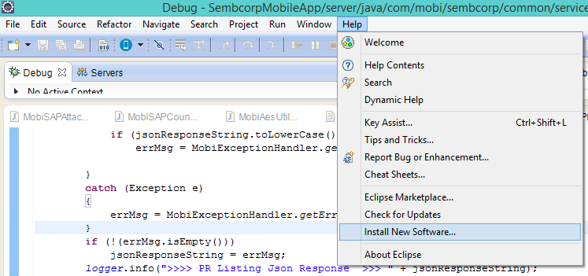

- Click Add, in the Add Repository popup, give a name for the plugin and click Archive.
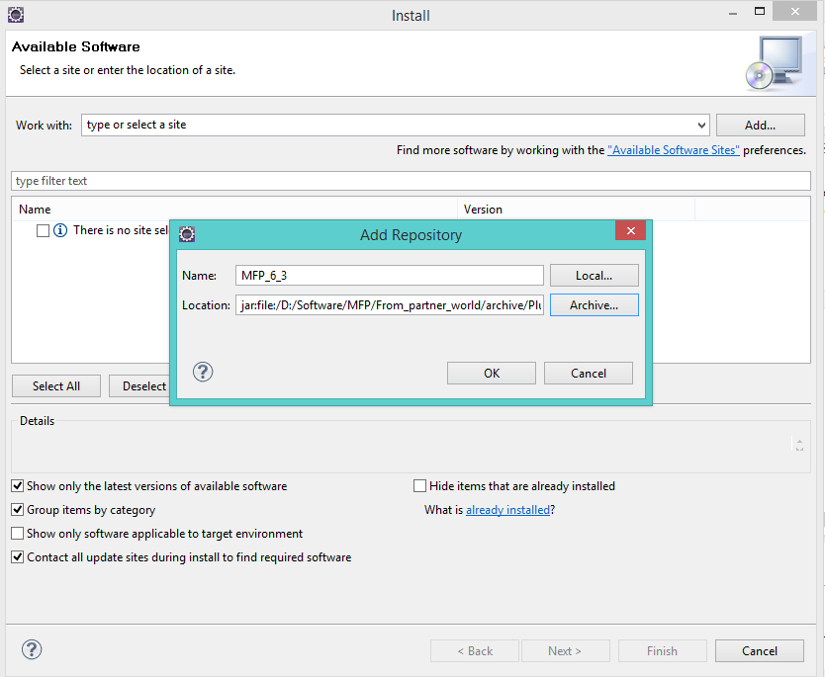

- Browse for the archived file MFPF_6.3_CE_ELP_UPD_IBM_MF_STUDIO.zip in your disk and select the file, and click ok.
- Now the install popup will display the softwares, available to install.
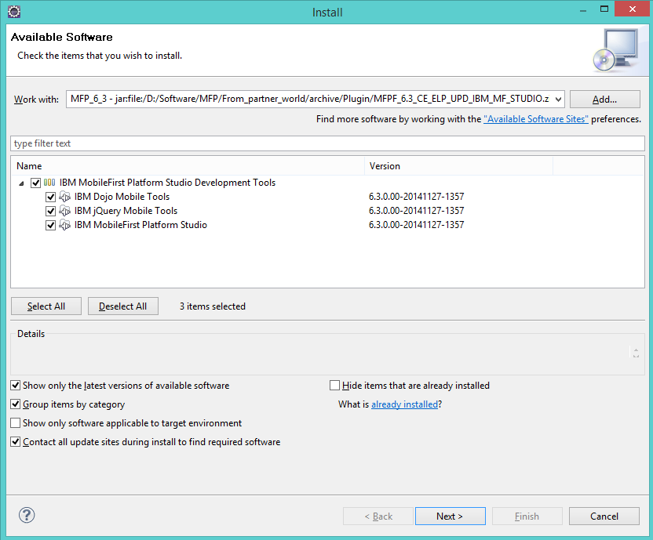

- Select All and click Next.
- This will finish the intallation process.
- Restart the eclipse for the changes to take effect.
- Once Restarted, Mobile First studio v 6.3 will be avaialbe along with mobile first development server for the development in the local environment.

Adding the iFix as Eclipse P2 Update
If the current version has any latest fix available download and save it in the local disk.
To add the fix, follow the below steps,

- Select Windows → Preferences
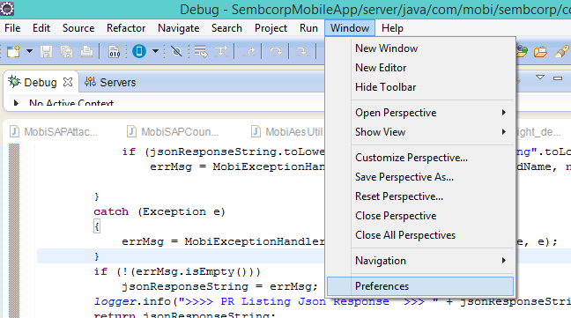

- Select Add in the Preferences popup
- In the Add Site popup, give a name for the fix, and click Archive to browse for the downloaded fix in the local drive.
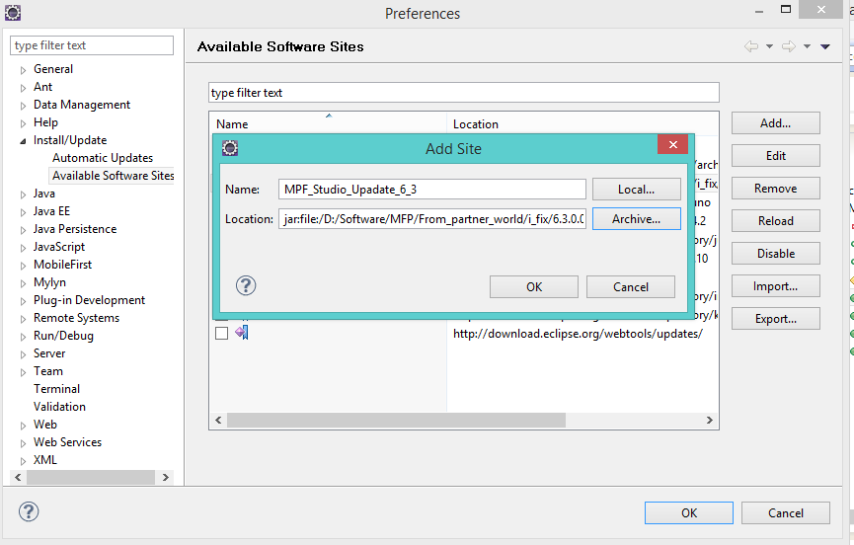
- Click OK.
- This makes the fix available in eclipse to update.
- Once this is done, you need to manually go and check for updates.
  - Click Help → Check for Updates
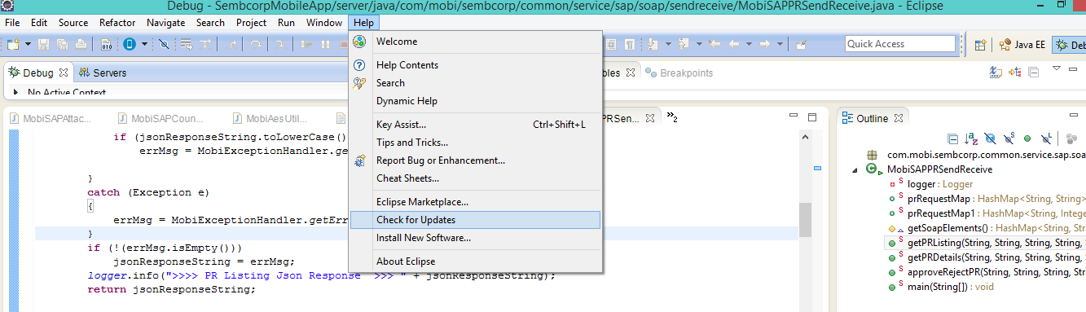

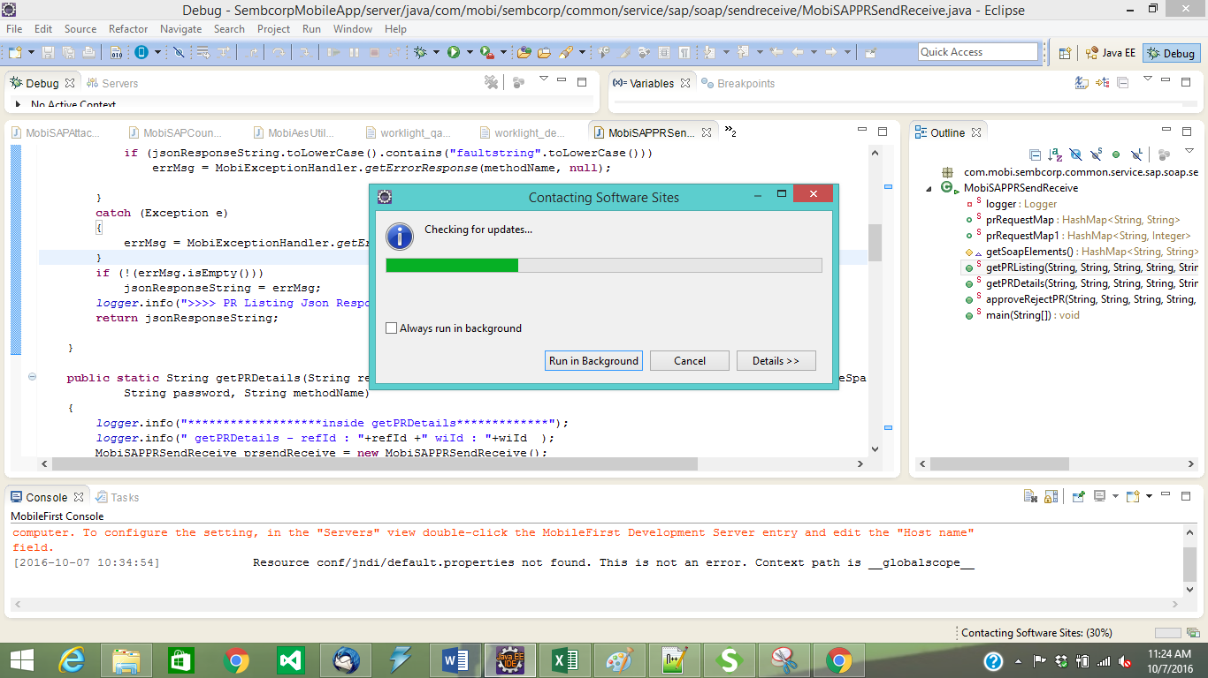

- This installs the iFix.

Once the plugin is installed, we will be able to create and work on mobile first projects. The mobile first icon should be available in the tool bar section if installation has been done properly.

